**Consideration of implementation, construction options.**

How would this project be implemented, what resources (hardware or software) are

needed? Are there any challenges or issues?

We are going to need laptops and computers that our team can use to develop, test and maintain our app. We will also need to run tests on the version of the app on phones as well.

The app will need a backend server to communicate with the app, a server is needed to track the user’s and app’s data, as well as push updates to the app.

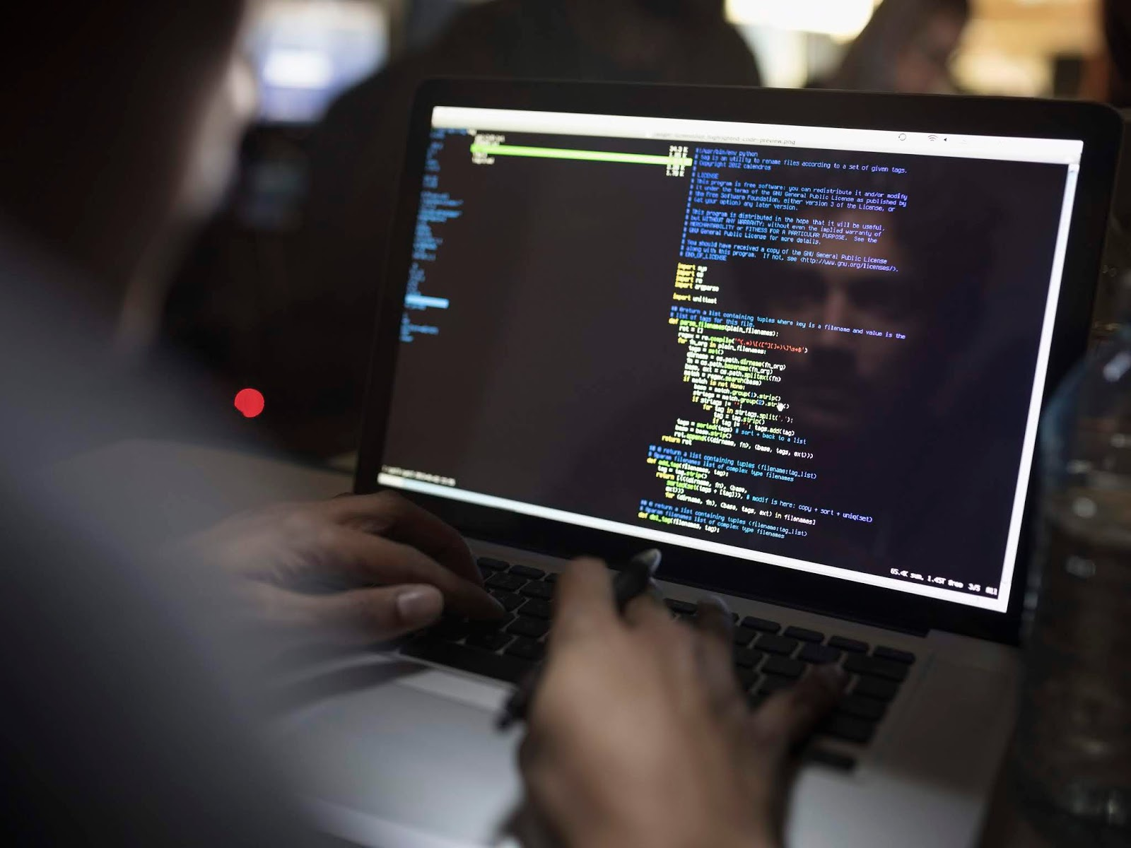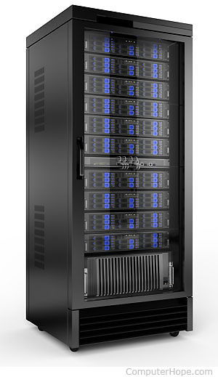

What software & Languages are going to be used to create the app?

**IDE**

We will need to use an IDE (Integrated Development Environment), an example of this would be XCode, an IDE used to create Apple apps. It has features such as a simulator, this is helpful to see how the app functions whilst in development and to run tests on it.

However, Visual Studio would be the best option to create an app across different hardware and devices, with the use of extensions we can add to an already powerful IDE targeted towards app development.

**Programming language and other technologies**

Java is a popular language used across the world to create apps, but we have decided to use C#. We can use it to our advantage as the language itself is very versatile and can be used across many devices with help of libraries such as Xamarin which we will use for mobile app development which will be the first stage of our project implementation as the website would be created in later stage.

For front end of web application, we are going to use angular which is popular JavaScript framework used to build client-side UI with clear and modern look

Asp.net C# framework will be used for server-side web development and its cross platform as well so the website could be used on any type of device that uses the browser.

Serverless services Is our go to as the app itself would not be a huge enterprise product there is no need to spend enormous amounts of budged on servers which would be overkill, serverless services such as AWS are perfect choice since it does not require much management from us when it comes to servers so this time can be allocated onto other sectors of the project as well.

GitHub will be also used to share the code remotely between the people in group to collaborate and organize it as well also in case of any problems with losing the progress code will be saved after is pushed as often the members of the groups work in different remote locations so it's important part of the development.

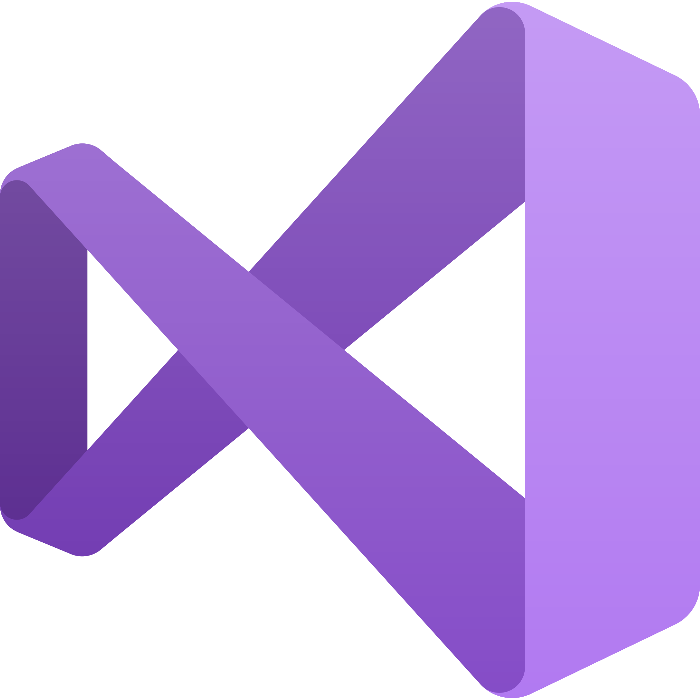

What is the range of options? How will you be prototyping this in this module?

How will students gain access to the app?

We hope to get our app available across app stores for smartphones and other devices such as laptops and desktops, as well as being able to download from our website as an APK or executable. Having more options for students to gain access to the app will make it more accessible and therefore mean that we will have a wider platform audience.

What platforms can use the app?

We will need to make sure when designing the app that we have feature variability as well as a flexible user interface that is adaptable to different devices. We want to create a functional app that should re-size and have a change resolution depending on the screen size, as well as be able to perform well across different devices as they have different specs. It will want to be compatible with as many devices as possible so that there are not any crashes or bugs causing people to have a loss of learning. To help with that we can use configuration-specific app resources to provide the dynamic app framework for different devices, giving maximum optimization for each one. Some of these platforms and devices are:

Smartphones

* Apple
* Samsung
* Huawei

Other

* Laptops
* Desktops
* Tablets

**Challenges of implementation**

* Work organization will be one of the key issues as there are problems with workload management
* Communication amongst the team
* Skills required to build the app
* Time management
* Making it compatible with as many different devices as possible